**Fast Food Marketing Campaign A\B Test**

**Business Goals**

To increase the sales for the new menu item.

**Business Objectives**

Identify the most effective marketing strategy and implement it in selected markets to drive sales growth for the new menu item.

**About the data**

The data consist of 7 columns, namely 'MarketID', 'MarketSize', 'LocationID', 'AgeOfStore', 'Promotion', 'week', 'SalesInThousands' . Among the columns, only 'SalesInThousands' is a numerical column. The remaining 6 columns are categorical columns.

**Analysis Methodology**

To analyse the performance for the 3 types of promotion strategy based on sales across all categorical columns and to analyse the sales by promotion type across the 4 week period.

**Some important charts and insights**

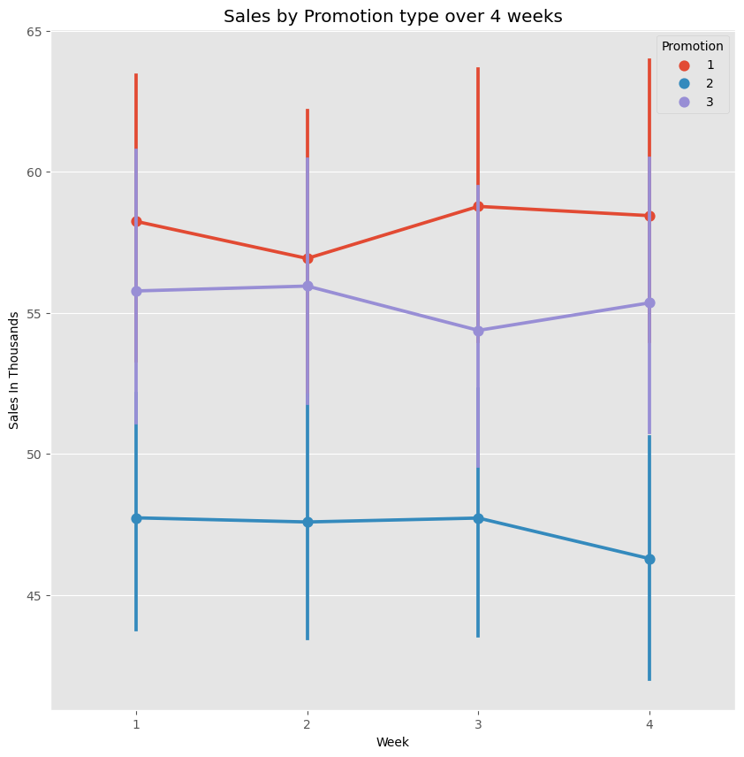

The sales by promotion across the 4 weeks has showed that promotion 1 generated the highest sales while promotion 2 generated the lowest sales. The sales is consistent across the 4 week period for all 3 types of promotiomns.

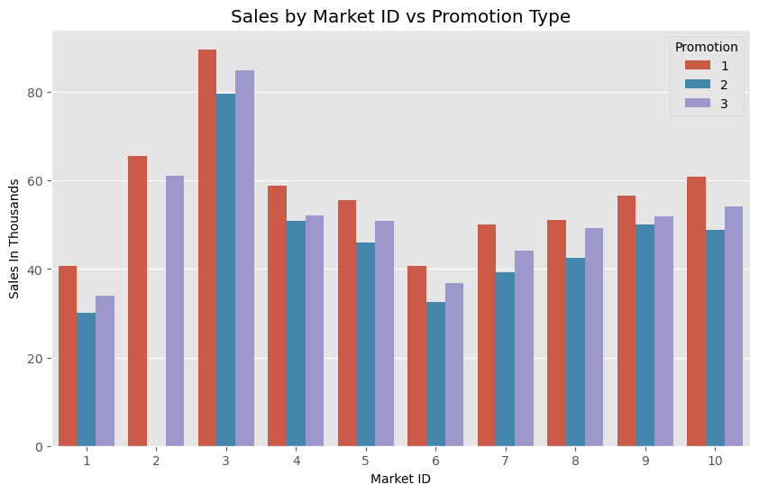

Market ID 3 has the highest sales, with promotion 1 as the promotion type generating the highest sales. Market ID 2 does not consist of sales generated from promotion2.

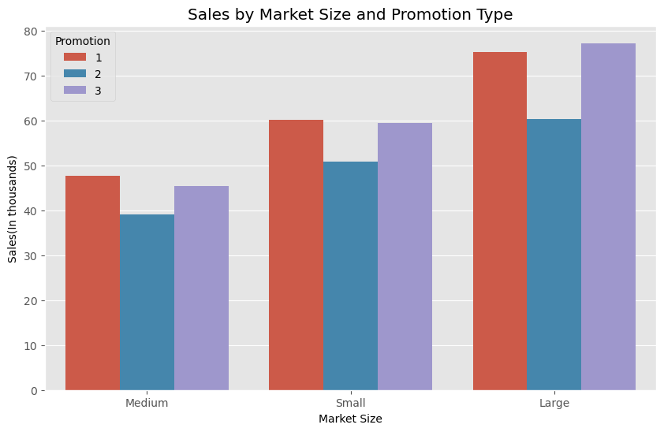

Large Market Size generated the highest sales with the sales mainly deriving from promotion 3, while Medium Market Size generated the lowest sales among all 3 market size.

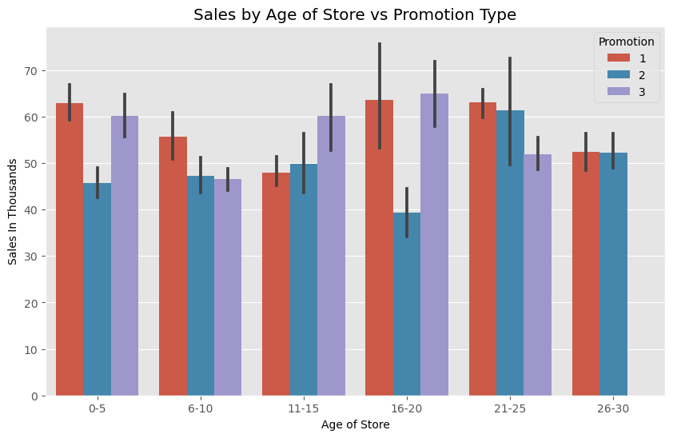

Most of the sales are generated from stores aged between 16-20, which is contributed by promotion 3. There is no sales generated from promotion 3 for stores aged between 26-30 years.

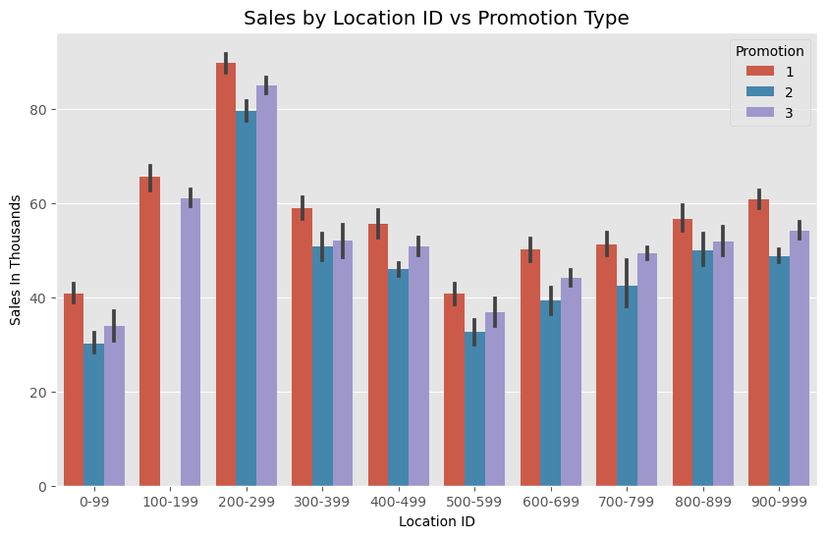

Location IDs between 200-299 generated the most sales, which is mostly contributed by promotion 1. No sales are contributed by promotion 2 for Location IDs between 100-199.

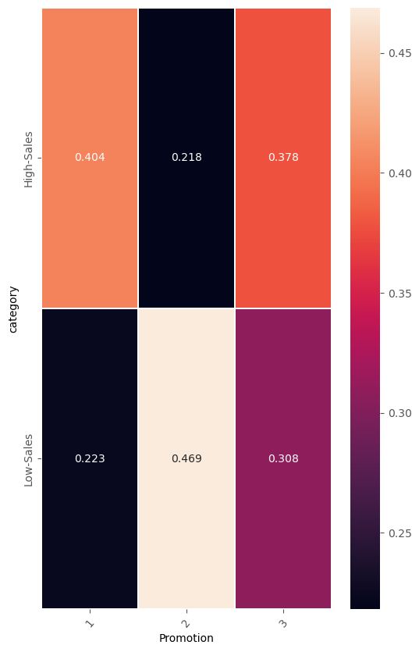

Most high sales (sales amount above the median value) are generated by Promotion 1, while most low sales are generated by promotion 2.

**Final Conclusion**

Among the 3 promotion types, promotion 1 generates the most sales while promotion 2 generates the least sales. The results are consistent across the analysis for all categories.

**Next steps for the business to take**

- The fast-food chain should adopt promotion 1 as their future marketing strategy to market their new product.

- The markets they should focus on are markets with the following characteristics: Large Market Size, Market ID 3, Location ID between 200-299 and stores aged between 0-5 years as these are the areas that generated the highest sales.